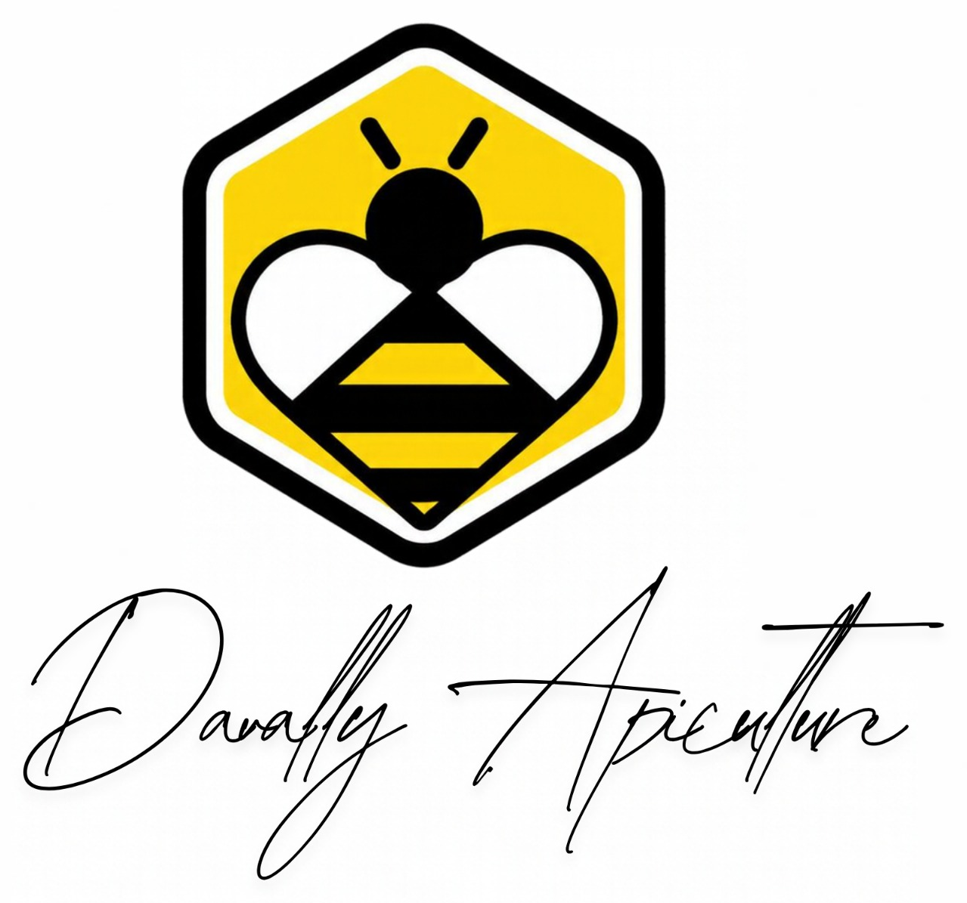
SUSTAINING ECOSYSTEMS, ONE QUEEN AT A TIME

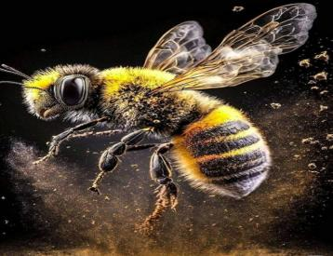 | 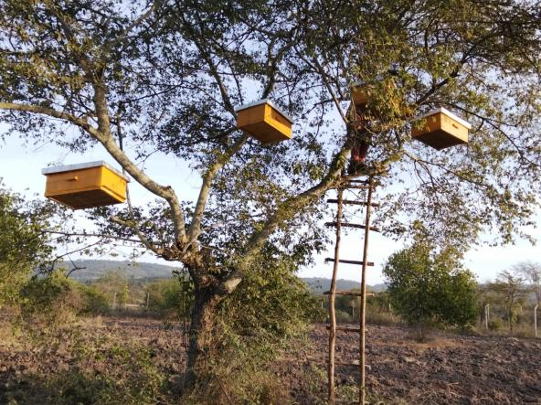

COMPANY PROFILE & PRICE CATALOGUE
Queen bee grafting • Apiary services • Colonised hives • Bio fencing
Tala, Machakos County, Kenya

About Davally Apiculture
Davally Apiculture Limited is a Tala-based apiculture company specialising in queen bee grafting of the African honey bee, Apis mellifera scutellata, and a full spectrum of apiary services. We help farms, conservancies and institutions build healthy bee populations that pollinate crops, restore habitat and create livelihoods.
From selective breeding to turnkey apiary installation, commissioning, maintenance and conservation-oriented bio fencing, we deliver one accountable partner from project design to execution.

HEADQUARTERS  Tala, Machakos | SERVICE AREA  National & regional | SPECIALTY  Queen bee grafting | BEE SPECIES  Apis mellifera scutellata
Core Competencies
01 Queen Bee Grafting  - Selective breeding and grafting for robust, productive queens  - Genetic management suited to local ecology, with disease-resistant traits  - Post-graft rearing support and queen shipping | 02 Apiary Installation & Care  - Design and set-up tailored to land, climate and forage  - Commissioning: hive placement, protective infrastructure, water and access  - Ongoing monitoring and seasonal hive management
03 Colonised Beehives  - Ready-to-use colonised hives for large-scale pollination and ecosystem support  - Quality assurance, warranty and after-sales service | 04 Conservation Bio Fencing  - Fencing that supports biodiversity, pollinator corridors and conservancy goals  - Materials and installation that fit ecological restoration projects
Why Davally
- Sustainability: enhanced pollination and biodiversity gains.
- Local strength: robust, locally adapted queen bees and colonies.
- Turnkey delivery: end-to-end support on every apiary project.
- Built for scale: services tailored to large-scale agriculture, research and conservation programmes.
Our Products & Services
1 | Queen Grafting & Rearing | Grafted queens, bulk breeding programmes and shipping
2 | Apiary Design & Installation | Home, farm, commercial and conservancy sites
3 | Commissioning & Start-Up | Hive placement, infrastructure and starter stock
4 | Maintenance Packages | Monthly or quarterly hive care and monitoring
5 | Colonised Beehives | Ready-for-deployment hives for commercial pollination
6 | Bio Fencing | Solutions for conservancies and agro-ecosystems
7 | Training & Technical Support | Capacity building for beekeeping teams
Who We Serve
- Large-scale farmers and agribusinesses needing reliable pollination  - Conservancies and wildlife reserves protecting pollinator health  - Agricultural research institutions and beekeeping cooperatives | - Government and NGOs working on biodiversity and sustainable farming  - Commercial buyers needing colonised hives for rapid deployment
Ready Hives
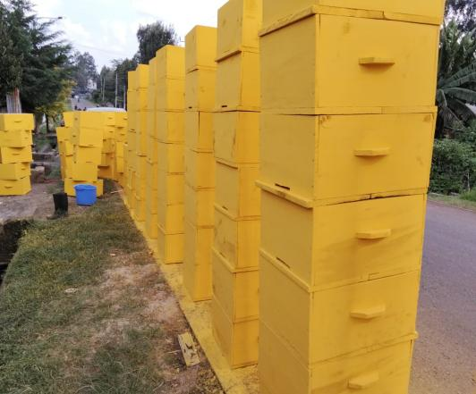 | Uncolonised hives, ready to order  Purpose-built hives, finished and ready for placement. Supplied empty for you to colonise, or colonised by our team for immediate pollination service.  - Standard Langstroth and other hive types  - Volume discounts: 5% off at 50+ hives, 15% off at 200+  - Delivery and installation available per site
Quality, Team & Impact
Quality and compliance
- Commitment to biosecurity and disease prevention
- Adherence to local beekeeping regulations and industry best practice
- Transparent specifications, warranty terms and service-level agreements
Team and expertise
- Apiarists skilled in African honey bee biology, grafting and hive management
- Field technicians for installation, maintenance and sensor-based hive monitoring
- Sales and technical support staff from project design to execution
Sustainability and social impact
- Promoting native pollinators and ecological resilience
- Creating livelihoods through bee-related jobs and training
- Conserving biodiversity through habitat-friendly products such as bio fencing
Partnerships
Strategic partnership with the National Beekeeping Institute (NBKI), alongside agricultural and conservation programmes.
Projects Delivered
A 20-hive apiary set at bee-landing level, ready for colonisation, Kamuthanga. | Installations completed across Machakos and neighbouring areas include:  - Kakuyuni  - Matetani  - Sengani  - Kilimambogo  - Kamuthanga  ...and other successful sites.
Price Catalogue
Local price catalogue in Kenyan Shillings (KES), effective 29 April 2026. Exchange rate used: 1 USD = 129.10 KES.
1. Queen Grafting & Rearing
SKU | Description | Price (KES) | Notes
QG-01 | Grafted queen bee (A. m. scutellata) | 645 – 2,582 per queen | By quality tier and season. Includes basic grafting service and rearing guidance.
QG-02 | Bulk breeding programme (10–50 queens) | 7,746 – 64,834 per batch | Custom breeding goals on request.
QG-03 | Queen shipping (within Kenya) | 1,287 – 6,458 per queen | Packaging included; delivery lead time varies by region.
QG-04 | Post-graft support and follow-up visit | 2,582 – 12,917 per visit | One-on-one consult and colony check; excludes travel beyond 50 km.
2. Apiary Installation & Commissioning
SKU | Description | Price (KES) | Notes
AI-01 | Site assessment and design consult | 645 – 3,245 per site | Includes site visit report and recommended layout.
AI-02 | Full apiary installation (per hive set-up) | 12,917 – 32,458 per hive | Includes frames, hive bodies, entrance reducers and basic accessories.
AI-03 | Infrastructure provisioning (water, fencing integration) | 25,834 – 129,170 per site | Based on site size and access.
AI-04 | Commissioning and starter stock | 19,375 – 77,500 per site | Includes initial colony installation and starter stocks.
3. Apiary Maintenance Packages
SKU | Description | Price (KES) | Notes
AM-01 | Monthly maintenance (per hive) | 649 – 2,582 per hive/month | Inspection, feeding if needed, basic health checks.
AM-02 | Quarterly maintenance (per hive) | 1,936 – 7,746 per hive/quarter | Includes disease monitoring and mite checks.
AM-03 | Disease management and monitoring | 1,287 – 6,458 per hive | Treatments and diagnostics billed separately if required.
AM-04 | Sensor-based hive monitoring | 12,917 – 51,670 set-up; 5,134 – 20,558 monthly | Optional; excludes hardware if client supplies own.
4. Colonised Beehives (Ready for Deployment)
SKU | Description | Price (KES) | Notes
HB-01 | Per hive (standard Langstroth/other) | 6,458 – 32,458 per hive | Based on hive type, size and age of colony.
HB-02 | Volume discount | 5% off at 50+ hives; 15% off at 200+ | Applies to hive price only; excludes delivery.
HB-03 | Delivery and installation | 2,582 – 12,917 per site | Considers transport distance and site accessibility.
5. Bio Fencing for Conservancies & Ecological Projects
SKU | Description | Price (KES) | Notes
BF-01 | Bio fencing, materials + installation | 260 – 2,582 per metre | Materials vary (reed, living barriers, etc.); custom options available.
BF-02 | Bio fencing per hectare | 326,070 – 1,935,000 per hectare | Based on density and design complexity.
BF-03 | Annual maintenance and replacements | 1,287 – 6,458 per metre/year | Includes inspection and parts replacement as needed.
6. Training & Technical Support
SKU | Description | Price (KES) | Notes
TR-01 | Basic beekeeping training | 6,458 – 12,917 per participant | Half-day to full-day options.
TR-02 | Advanced queen-rearing/grafting training | 12,917 – 25,834 per participant | Certification where applicable.
TR-03 | On-site technical support package | 12,917 – 32,458 per day | Travel and lodging not included unless specified.
7. Optional Add-Ons
SKU | Description | Price (KES) | Notes
OA-01 | Insurance/warranty options | 1,287 – 5,134 per hive/year | Per hive or project.
OA-02 | Packaging and branding for resale | 1,287 – 6,458 per unit | Custom branding available; minimum order may apply.
Terms & Notes
- Currency: Kenyan Shillings (KES). All prices exclude VAT where applicable.
- Lead times: installation and grafting vary by season; confirmed at quote.
- Inclusions: most prices include standard materials, basic equipment and standard support as described in the SKU.
- Exclusions: specialist equipment, rare hive types, long-distance transport beyond the agreed radius, weather-related delays, and disease treatment beyond standard monitoring are billed separately.
- Pay by Till: Till No. 1801420 (DAVALLY APICULTURE).
- Payment terms: 30 days net for approved institutional clients; 50% upfront and 50% on completion for projects; retainage may apply to large contracts.
- Warranty: 90-day workmanship warranty from installation; colony health is covered by separate beekeeping management terms.
- Safety & compliance: all work follows local beekeeping regulations and biosecurity best practice.
Where We Work
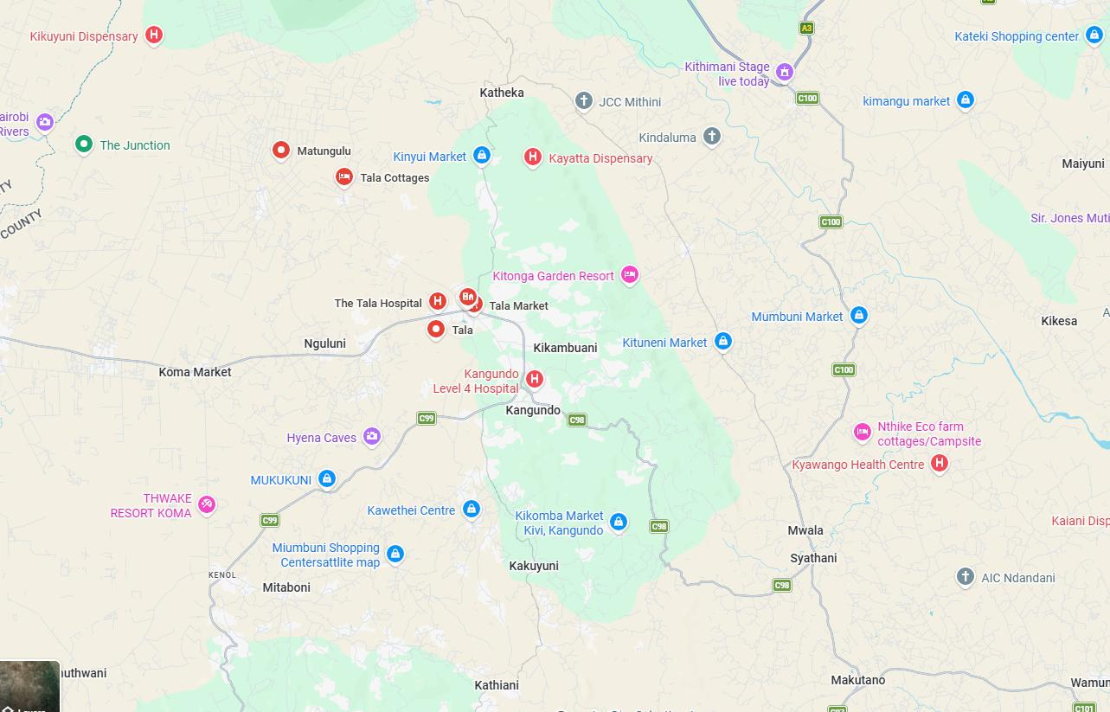
Operating area around Tala, Kangundo and Kakuyuni, Machakos County.
LET’S BUILD YOUR APIARY
Email david.kyalo@muajiri.com
Mr. Maveke 0722 260 670
Mr. David 0708 701 569
Address Tala Town, Machakos County, Kenya
Payment Till No. 1801420 (DAVALLY APICULTURE)
Business Reg. No. BN-79S6OBMR
Sustaining ecosystems, one queen at a time.

Certificate of Registration
Registered under the Registration of Business Names Act (Cap. 499), Republic of Kenya.
BUSINESS NO.  BN-79S6OBMR | REGISTERED  30 June 2026, Nairobi | REGISTERED OWNER  David Mwangangi Kyalo

